Jonny sims p6 tag practice

Html code

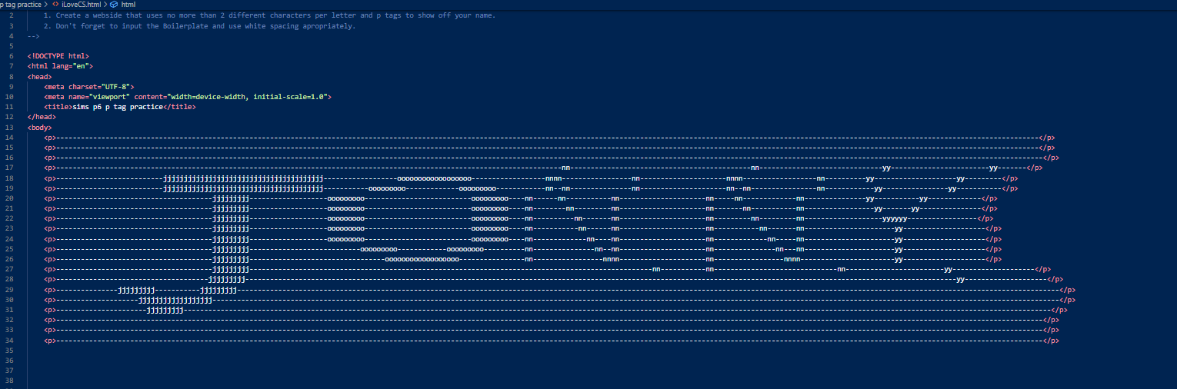

Output

